1. Write a Python Program to perform brute force attack on the cipher text “dvvkzecfssprkkve"

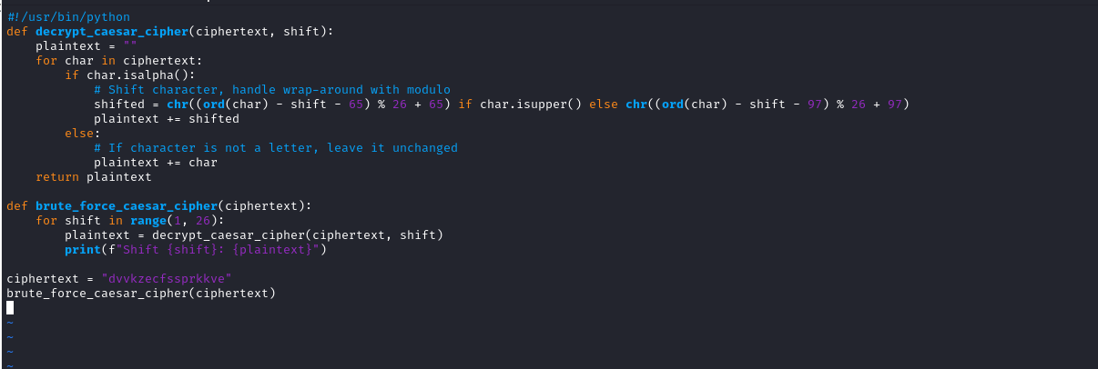

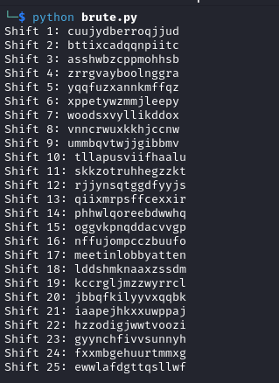

2. Write a Python program to use brute force attack to decipher the message.

Assume Affine cipher was used and "ab" is encrypted as "GL". Find the value of keys.

XPALASXYFGFUKPXUSOGEUTKCDGFXANMGNVS

#!/usr/bin/python

import string

from sympy import mod_inverse

def affine_decrypt(ciphertext, a, b):

alphabet = string.ascii_uppercase

m = len(alphabet)

a_inv = mod_inverse(a, m) # Find modular inverse of a modulo m

plaintext = ""

for char in ciphertext:

if char in alphabet:

y = alphabet.index(char)

x = (a_inv * (y - b)) % m

plaintext += alphabet[x]

else:

plaintext += char

return plaintext

def brute_force_affine(ciphertext, known_plaintext, known_ciphertext):

alphabet = string.ascii_uppercase

m = len(alphabet)

known_plaintext = known_plaintext.upper()

known_ciphertext = known_ciphertext.upper()

# Create a dictionary of all possible (a, b) pairs

for a in range(1, m):

if gcd(a, m) != 1:

continue # 'a' must be coprime with m (i.e., 1 < a < 26)

for b in range(m):

# Encrypt known plaintext using (a, b) to check if it matches the known ciphertext

test_ciphertext = ""

for char in known_plaintext:

if char in alphabet:

x = alphabet.index(char)

y = (a * x + b) % m

test_ciphertext += alphabet[y]

else:

test_ciphertext += char

if test_ciphertext == known_ciphertext:

# Found the correct (a, b) pair

print(f"Found keys: a = {a}, b = {b}")

# Decrypt the ciphertext using found keys

decrypted_message = affine_decrypt(ciphertext, a, b)

print(f"Decrypted message: {decrypted_message}")

def gcd(a, b):

while b:

a, b = b, a % b

return a

ciphertext = "XPALASXYFGFUKPXUSOGEUTKCDGFXANMGNVS"

known_plaintext = "ab"

known_ciphertext = "GL"

brute_force_affine(ciphertext, known_plaintext, known_ciphertext)

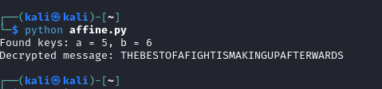

1. Encrypt the plain text using Rail Fence cipher

def encrypt_rail_fence_cipher(plain_text, num_rails):

rail_matrix = [['\n' for _ in range(len(plain_text))]

for _ in range(num_rails)]

# Variables to determine the direction of zigzag

dir_down = False

row, col = 0, 0

# Fill the rail matrix in a zigzag pattern

for char in plain_text:

# Place the character in the current row

rail_matrix[row][col] = char

col += 1

# Change direction if we hit the top or bottom

if row == 0 or row == num_rails - 1:

dir_down = not dir_down

row += 1 if dir_down else -1

cipher_text = []

for i in range(num_rails):

for j in range(len(plain_text)):

if rail_matrix[i][j] != '\n':

cipher_text.append(rail_matrix[i][j])

return "".join(cipher_text)

plain_text = "HELLO WORLD"

num_rails = 3

cipher_text = encrypt_rail_fence_cipher(plain_text, num_rails)

print("Cipher Text:", cipher_text)



4. Decrypt the cipher using Rail Fence

AAIUJ SIHBE KTEAO TEADE SNUTF EAEMR TAHSA

RHROA YHNFO AITTE EHCBO FVCAT RNMNS NUTFE

RASHL WFHLN HIUJS IHTKS OEHNI FISAE FNTIG

RMRSO LSTIS OKIEH PEOE

def decrypt_rail_fence_cipher(cipher_text, num_rails):

# Create an empty matrix to mark the positions in the zigzag pattern

rail_matrix = [['\n' for _ in range(len(cipher_text))]

for _ in range(num_rails)]

dir_down = None

row, col = 0, 0

for i in range(len(cipher_text)):

if row == 0:

dir_down = True

if row == num_rails - 1:

dir_down = False

# Place a marker at the current position

rail_matrix[row][col] = '*'

col += 1

row += 1 if dir_down else -1

index = 0

for i in range(num_rails):

for j in range(len(cipher_text)):

if rail_matrix[i][j] == '*' and index < len(cipher_text):

rail_matrix[i][j] = cipher_text[index]

index += 1

result = []

row, col = 0, 0

for i in range(len(cipher_text)):

if row == 0:

dir_down = True

if row == num_rails - 1:

dir_down = False

if rail_matrix[row][col] != '\n':

result.append(rail_matrix[row][col])

col += 1

# Move to the next row in the current direction

row += 1 if dir_down else -1

return "".join(result)

cipher_text = (

"AAIUJSIHBEKTEAOTEADESNUTFEAEMRTAHSARHROA"

"YHNFOAITTEEHCBOFVCATRNMNSNUTFERASHLWFHLN"

"HIUJSIHTKSOEHNIFISAEFNTIGRMRSOLSTISOKIEHPEOE"

)

num_rails = 4

plain_text = decrypt_rail_fence_cipher(cipher_text.replace(" ", ""), num_rails)

print("Plain Text:", plain_text)

